SPORTS NEWS

East Vanua Lava Futbol Lig I Open
Futbol lig blong Sola I openem championship program blong hem long namba 2 Jun 2007. Tu match oli bin plaem, long 13:30 I gat Arep vs. Sola, afta Sola I skorem 3, Arep 1 nomo. Afta long 15:00 I gat Shalom (Diocese) vs. Qulstar Futbol Klab be match I kansel from tim I no kam.

Volleyball
Long 13 Jun I gat wan meeting widem olgeta female volleyball blong setemap nyufala executive blong lig mo semtaem lukluk long date blong opening blong volleyball lig.

NOTICES
Sapos yu gat wan notice olsem: fundraising, birthday, mared, ol event, yu save telem long Torba Times I putum

GAUA ISLAND ARTS FESTIVAL COMPETITION
Date: 18-20 September 2007
Auerr Village, Gaua

Prizes will be given to the best performance of the following cultural activities:

Namag Dance (men) - Quat Dance (men) - Neleng Dance (women)
Water Music (women) - Weaving (women) - Carving (men)
Traditional Dress show for both men and women

For further information, contact Mr Charles Bice (38504) or the Torba Tourism Office, Sola – Mr. Charles Smith & Mr. Reginald Tari (38550)

Mrs. Veronica Abel I telem se hemi gat wan stoa blong ol second hand ting olsem klos, ol buk, beddings, klos blong ol pikinini, sus mo moa. Stoa I open evri satede. Hemi stap antap rod, behind haos blong Jimmy Jones.

THE MARKET HOUSE
Fine Dining in a Relaxed Environment
Open 7 days a week. Our Exciting Menu Changes Daily

THE TORBA TIMES
Issue 1, 8 June 2007 Price: 50VT
Newspaper Blong Yumi Long Torba

BRIDGE OVER TROUBLED WATER?
SOLA – One of Vanua Lava’s most well-known attractions are the twin rivers of Alligator River and Silver River. The island of Vanua Lava is the only place in Vanuatu where there are crocodiles, and local residents remember fondly self-styled Australian “Crocodile Hunter” Steve Irwin’s visit several years ago to repatriate a wayward alligator back to his home island. There are few crocodiles on the island, and though they are known to eat pigs and local chickens, they have never killed a human being. By all accounts the crocodiles are a source of pride, a unique presence on the islands of Vanuatu. Silver, or Sulphur, River is also well-known, as the volcanic water are known to heal wounds. Yet stories of close encounters with crocodiles persist, as the rivers are a central crossing point for people travelling to Sola from Port Patteson and beyond.  Local Sola resident, Mrs. Irene Sovan, told the Torba Times: “Long yea 1988, taem ia mi stap wok long jioj long Port Patteson olsem secretary/typist. | 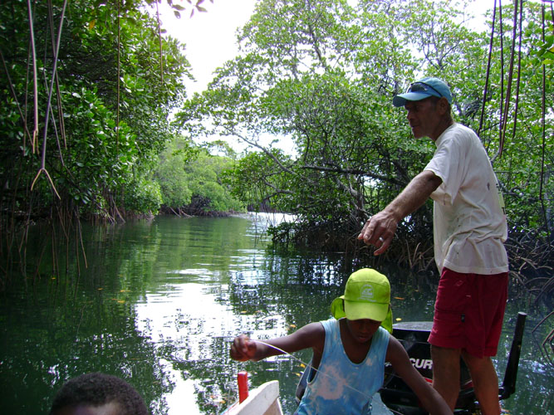  Captain Desmon Atkins widem boe blong hem Edward, long Alligator River  Mi kam blong go bak long haos. Mi stap long smol station, nem blong hem Seremba Plantation. Bifo mi go long haos mi mas yusum dugout blong krosem Silver River. Taem mi wantem go insaed long kanu mi faenaot se crocodile hemi laedaon folem kanu. Hemi putum maot blog hem antap long blong nambaura. Wan saed leg blong mi I go insaed long kanu, afta mi lukem crocodile. Mi fraet tumas. Mi mi singaot, afta mi no save krosem. Famili blong mi I kamdaon tekem kanu. Mi klaemem wan wud afta las brada blong mi I kam sutum crocodile long hed widem iron spear. So crocodile hemi ron. Long moning dadi blong mi hemi go long sanbij hemi luk crocodile hemi silip long sanbij bakagen.”  Cont. – p. 2

Cont. from. p. 1 – On Saturday, May 27, Tourism Officer Mr. Reginald Tari, accompanied by new Sola resident Ms. Elizabeth Bransfield, travelled by boat to Alligator and Silver River with Captain of the Provincial boat Mr. Desmon Atkins, following a suggestion by local residents that a permanent or semi-permanent bridge over the river should be considered for funding by the European Union or other possible donors. It is also suggested that the area be developed further for tourism purposes. The Torba Times welcomes comments and letters regarding this issue. Sapos yu telem, mifala I putum insaed.  Rotarians Arrive: Begin Construction of Hospital  SOLA – Seven Australian members of the International Rotary Club have arrived in Sola on Monday, 28 May, 2007, and begun construction of the new hospital. The first team has laid down concrete flooring with the help of local residents, and will be followed by other teams throughout the year. A further group has arrived Monday, 4 June, with more expected.  P. 2 | Ol Artist Long West Vanua Lava oli Mekem Gud Success Widem Local Carvings  VUREAS BAY – Mr. Swithun Milroy I telem se ol arist blong West Vanua Lava I openem wan maket blong ol carvings long 22 Mei 2007 long taem ia oli selemaot ol carvings we mani blong hem I kasem 100,000VT. Hemia hemi wan kas mani we artist I bringim I kam inside long aelan. Mr. Milroy I telem: “Taem mi kasem Vila wan taem, mi mitim widem wan man Franis, hemi man blong pem ol artefacts. Long last yea, hemi spendem 150,000VT long Vureas Bay mekem total blong 250,000VT finis. Befo, hemi spendem 300,000VT long Gaua. Ol local carvings oli go long wan private museum long Vila.” Hemi wan gudfala samting blong yumi long Torba. Sapos yu wan artist yu save mekem carvings mo yu nidim moa information yo kontaktem Mr. Milroy long Vureas Bay.  Father Luke Dini Brings Donors To Mota Lava  MOTA LAVA – Well-known figure in the local community, Father Luke Dini, was recently in the national news following his encouragement of donors to come to the small island of Ra, where water shortages remain a problem. The Torba Times hopes to offer wider coverage of water issues in a future edition.
  THE TORBA TIMES
  Newspaper blong yumi long Torba
  Sola Post Office
  Sola
  Vanua Lava
  Torba
  Republic of Vanuatu

Island Court Visits Ureparapara  LESEREPLA – Court Clerk, Mrs. Evelyn Hopkins, accompanied by the three judges of the island court, Mr. David Melsikteltok, Mr. John Wasarak and Mr. Manasseh Wownd, visited Ureparapara between the 14 and 17 of May. The roving court landed first at the village of Lehali on the Western side of the island, where the clerk engaged in a programme of awareness-raising with the local community. The court then moved to the village of Leserepla, Dives Bay, for a session of the island court. The Torba Times I telem: wok blong kot hemi wan gudfala samting blong yumi long Torba. Mifala I wantem mekem wan bigfala coverage blong wok blong kot long future edition.  New Torba Secretary-General Set To Arrive from Vila  VILA - New Secretary-General for the Torba Provincial Government, Mr. Shadrack Welegtabit, is set to arrive in Sola in July or August of this year (depending on previous work commitments) to take up his position. He will reside in the Secretary-General’s house, with current resident -  P. 3 | 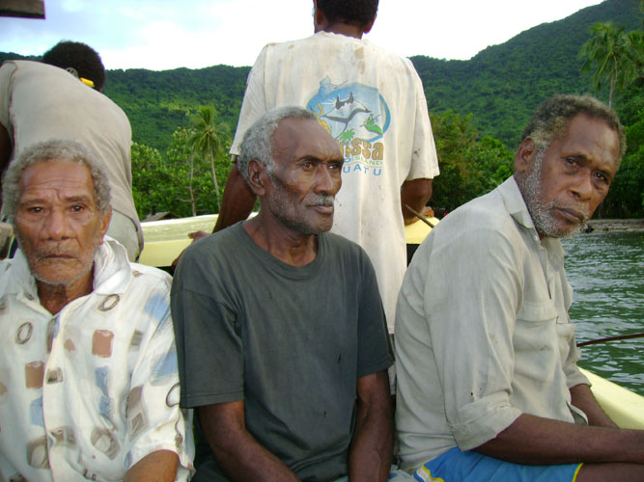  The three judges of the Island Court en-route to Dives Bay  Cont. - Planner Mr. Henri Nin, moving to new premises nearby. The Torba Times would like to welcome Mr. Welegtabit, of Mota Lava Island, in his new job.  New Airport for Pakea Island  PAKEA – The small island of Pakea, off the coast of Vanua Lava, now has a new airstrip built by local workmen. Current lease-holder, Mr. Jimmy Jones, is set to leave Pakea, with the lease going to a new resident. The airstrip will reportedly be used privately, and not be on the Air Vanuatu itinerary. The Torba Times hopes to report on this in more depths in a future edition.  Nyufala Newspaper Blong Torba I Kamaot  Torba Times hemi wan nyufala samting blong yumi long Torba, from yumi no gat newspaper, o radio, o television, o evri samting blong communication long ples ia. Sapos yu laekem Torba Times yu save singaot! Torba Times I stap widem Internet so ol man long Vanuatu widem Vila I save ridim news blong yumi fasteam.

